Scripts for Scene: **WT_MotorSide**

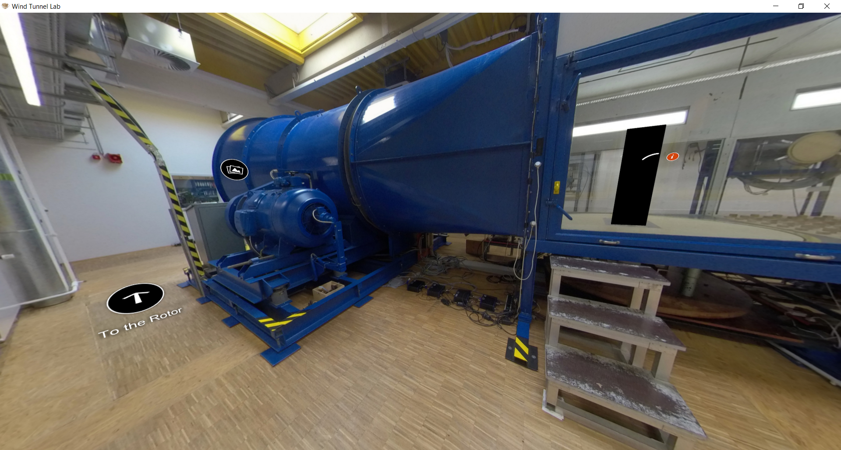

|  |  |  |
| --- | --- | --- |
| Nr | Hotspot (see red arrow) | Script |
| 1 | Hotspot: Motor | Figure+Text  Slide 1-Figure :    Slide 1-Text :  To move the fan/rotor of the wind tunnel, in where the wind flow can be produced inside the wind tunnel, AC three-phase current motor is used. The AC motor type is KLA 1045-6 from Piller. The three-phase current motor has the voltage level 400V, 100 kW Power, and the rotation of the motor ranges between 30-1500 RPM. For the maintenance of the motor, lubrication is conducted once a year. |